**Welcome to the EnglishTek Virtual Dialog**

Practice listening and speaking through your computer. To access the activities, please follow the instructions below. If you are installing this software at home or at school, ask your parents, teacher, or computer lab technician for help.

**Make Sure Your Computer Has the Following:**

* Windows Vista/7/8/10
* Dual Core CPU 2Ghz or higher
* 2GB RAM
* 100MB free space on the hard drive
* 256kbps broadband Internet connection or faster
* Good quality headset with microphone

**Installing the Client:**

1. Make sure that you close all running programs before running the installer.
2. Run the installer.
3. Follow the installation wizard.
4. Run the program.

**How to Use Your Client:**

Setting Up Your Microphone

1. Plug in your headset to the proper input jacks of your computer. Current standards use the pink plug for the microphone and the green plug for the speakers.
2. Right click on the Volume icon on the Windows system tray

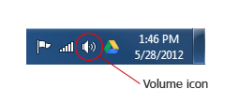

Select Recording devices.

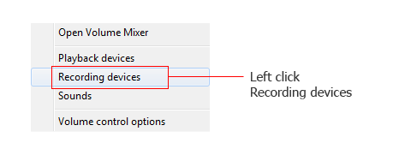

1. Left click on the default recording device on the list. You may try speaking into the microphone to see if you are getting a signal. This is indicated by the green bar on the right.

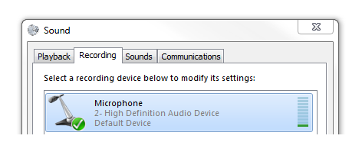

1. Left click on the Properties button below.

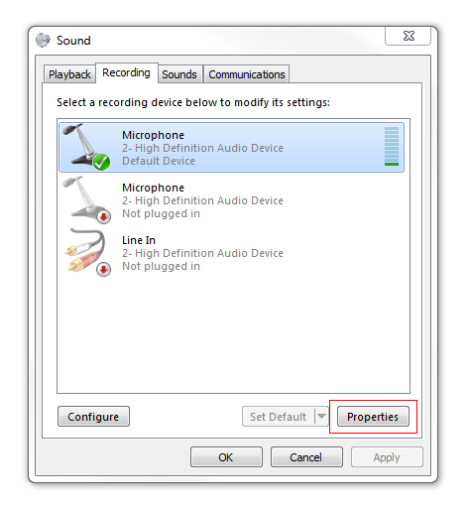

1. Left click on the Levels tab.

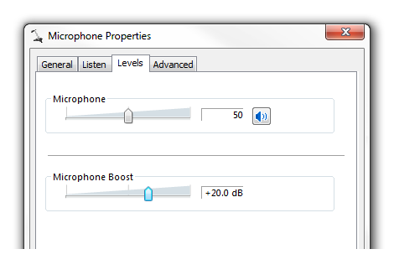

1. Slide the Microphone slider to 50 and the Microphone Boost slider to +20.0 dB.

For most computers and headsets, we tested, these values seem to give the best responsiveness. However, you may tweak your microphone volume settings if you are having problems with the Virtual Dialog responsiveness.

Basic Troubleshooting:

* Check if your system fits the requirements.
* Make sure that you have a stable broadband Internet connection.